iSocial is a [U.S. Department of Education funded i3 project](https://ies.ed.gov/ncser/projects/grant.asp?ProgID=56&grantid=790). It is a design-based research project to construct a 3D collaborative virtual learning environment (3D CVLE) for teaching social competence to youth with Autism Spectrum Disorders (ASD). Incorporated the Social Competence Intervention based on a framework of Cognitive Behavioral Intervention: SCI-CBI, iSocial is to improve the social behavior of youth with autism in both virtual and natural settings. Immersive simulation such as in 3D virtual environments is increasingly being viewed as an enabling technology that transcends traditional educational boundaries and allows individuals to acquire the competencies needed for educational settings. Collaborative learning in 3D virtual world has shown significant growth in supporting groups of learners in the complex and highly interactive simulations. The potential benefits of using a 3D game-based virtual environment to teach social competence for autistic youth include engaging distant learners in the game-based role-playing learning activities and fostering social interactions among avatar mediated learners in a simulated, curriculum-enriched environment without suffering real-world consequences and in some formats without trying the patience of their peers or teachers. This project aims to study how 3D game-based virtual environments can be used to help autistic youth learn and how autistic youth learn in such an environment.

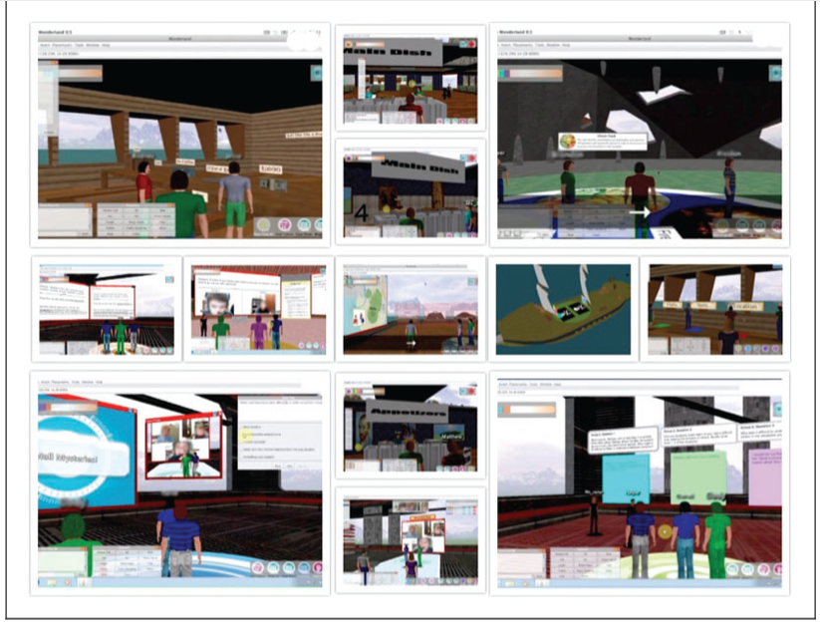

Screenshots of iSocial Curriculum

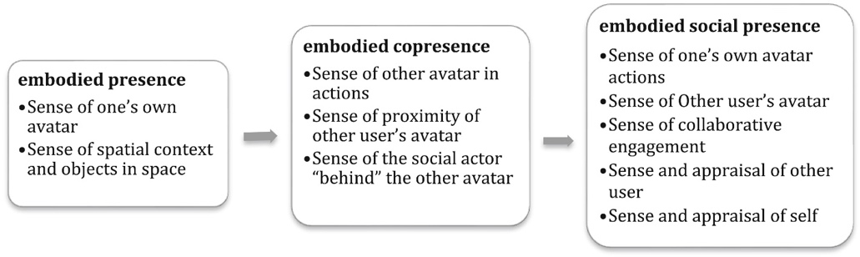

Embodied Social Presence development framework

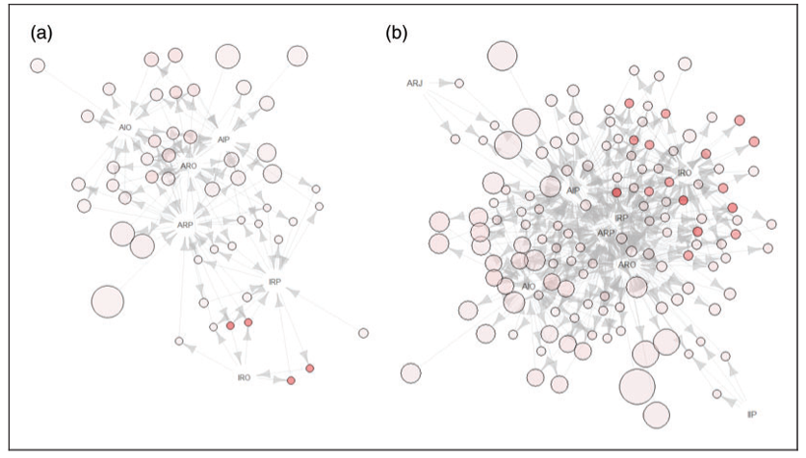

Rules Visualizations of Nongame and Game Groups. (A) Non-game activities rules. (B) Game activities rules

Publications:

Wang, X., Laffey, J., Xing, W., Ma, Y., & Stichter, J. (2016). Exploring embodied social presence of youth with Autism in 3D collaborative virtual learning environment: A case study. *Computers in Human Behavior*, *55*, 310-321.

Wang, X., Laffey, J., Xing, W., Galyen, K., & Stichter, J. (2017). Fostering verbal and non-verbal social interactions in a 3D collaborative virtual learning environment: a case study of youth with Autism Spectrum Disorders learning social competence in iSocial. *Educational Technology Research and Development*, *65*(4), 1015-1039.

Wang, X., & Xing, W. (2018). Exploring the influence of parental involvement and socioeconomic status on teen digital citizenship: A path modeling approach. *Journal of Educational Technology & Society*, *21*(1), 186-199.

Wang, X., Xing, W., & Laffey, J. M. (2018). Autistic youth in 3D game‐based collaborative virtual learning: Associating avatar interaction patterns with embodied social presence. *British Journal of Educational Technology*, *49*(4), 742-760.

Wang, X., & Xing, W. (2021). Supporting youth with autism learning social competence: A comparison of game-and nongame-based activities in 3D virtual world. *Journal of educational computing research*, 07356331211022003.